INT.119.0 version 3.0 SAP CR25_045 Address Validation

Functional and technical design specification

Innehållsförteckning

1 Introduction
1.1 Versioning
1.2 Contacts
1.3 References
1.4 Background
1.5 Terminology
2 Process description
2.1 Pre-requisites, rules and assumptions
2.2 Current process description
2.3 New process description
2.4 Impact on other processes
3 Functional and technical specification
3.1 Functional solution
3.2 Technical solution
3.3 Error-handling and logging
4 Miscellaneous
4.1 Application management
4.2 Security
4.3 Authentication and authorizations
5 Testing
5.1 Testing information
5.2 Test cases
6 Closing
6.1 Risks
6.2 Suggestions for improvement
6.3 Open questions
7 Appendix

Introduction

Versioning

Version | Date | Name | Description
0.1 | 2025-03-19 | Andreas Kvarnö | First draft
0.2 | 2025-04-01 | Andreas Kvarnö
0.3 | 2025-09-30 | Andreas Kvarnö
3.0 | 2026-01-29 | Andreas Kvarnö

Contacts

Name | Role | Organization
Andreas Kvarnö | Master data | CGI
Madeleine Jacobsson | Order To Cash | ES
Tomas Kuniholm | IT | ES

References

ID | Source | Reference type

Background

Sonepar uses an external service provider (Geposit) to have an updated register of valid addresses in Sweden.

This register of valid addresses is to be matched against SAP Business Partners with country code SE with the purpose of:
- During maintenance (creation/change) of BPs preventing entry of an invalid address
- During update or register of valid address, identify those BPs that have an address that is no longer valid
NB: The same table (ZSD_ADR_VLD) that will be used for BP address validation will also be used for sales order address validation.

Comments concerning version 3.0: in previous version address type was a part of the validation criteria. Since it has been decided to only upload relevant address types to table ZSD_ADR_VLD, with this version it is no longer relevant to use address type as a validation criterion.

Terminology

Term | Description

Process description

Process for validating address during regular maintenance of BP.
During creation and change of BP (see details for functional solution) SAP will prompt an error message (red) in case of entry of invalid address.

Process for validating addresses after update of underlying address table.

The following process will apply when Sonepar receives a new address register from Geposit

- Step 1. Sonepar will receive a new register from Geposit. Sonepar extracts the existing table from SAP (or has it stored somewhere outside of SAP). Outside SAP there will be analysis of which
  - Postal codes that disappear
  - Cities that disappear
  - Combinations of city and postal code that change
- Step 2. Results from step 1 will be used as filter criteria to extract BPs that are affected of changes in address register.
- Step 3. Sonepar will upload the latest version of address register from Geposit. Existing values will be overwritten.
- Step 4. Sonepar will manually or via mass change app maintain BPs identified in step with valid address data.
- Step 5. Sonepar will, as an extra precaution, run a background to verify that all BPs have address data that is consistent with the updated table.

Pre-requisites, rules and assumptions

N/A

Current process description
N/A

New process description
N/A

Impact on other processes

For general information:
CR040 has dependency to CR045. The requirement in CR040 is to set transportation zone and default unloading point in BP master data based on a) validated postal code and city (CR045) in the BP master data, and b) custom table storing postal code, city, transportation zone and default unloading point.
Hashini has built CR044 (address validation in order)

Functional and technical specifications

Functional solution

Address Validation During Maintenance of BP

Address validation for BPs is:
- Valid for manual creation of BP through dialogue transaction, both GUI (t-code BP) and Firori apps (Maintain BP, Manage Business Partner Master Data, Manage Supplier Master Data & Manage Customer Master Data).
- Valid for manual change of BP through dialogue transaction, both GUI and Firori apps. Validation should also take place when using Fiori mass change apps.

Selection Criteria for BPs for which address validation is relevant
For reasons of flexibility there must be a table of criteria for which address validation should apply [should be as any SAP input field, where specific values/ranges can be included or excluded]

Characteristic | Table-Field
BP Number | BUT000-PARTNER
BP Grouping | BUT000- BU_GROUP
Country Code | ADDR1_DATA- COUNTRY
Archiving Flag | BUT000- XDELE  There should be the possibility to  - Include BPs with archiving flag  - Exclude BPs with archiving flag

In case a field is blank there is no discrimination criteria [as a regular SAP input field]

Clarification to FS as of 2025-12-18
Business Partner - Will be maintained as EXCLUDE always in parameter table
Archive flag - Will be maintained as EXCLUDE always in the parameter table
BP - 3000000040 - archive flag unchecked
table it is maintained as exclude
Validation should take place

BP - 300000050 - archive flag is checked
table it is maintained as exclude
Validation shouldn't take place

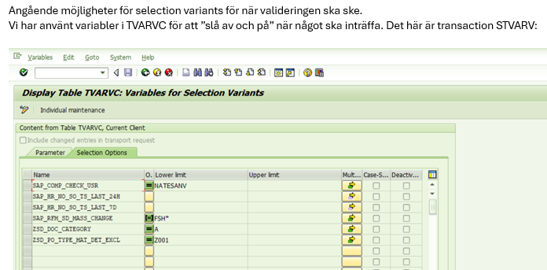
Criteria for validating address

The address of the BP will be matched against reference table ZSD_ADR_VLD, which contains
- Valid postal codes
- Valid cities
- Valid combinations of cities and postal codes

Table ZSD_ADR_VLD
Field POST_CODE is for postal code
Field LOCALITY is for locality

Fields to be compared between BP and address table
Field | Table Name BP | Field Name BP | Reference field table ZSD_ADR_VLD
Postal Code | ADDR1_DATA | POST_CODE1 | POST_CODE
City | ADDR1_DATA | CITY1 | LOCALITY

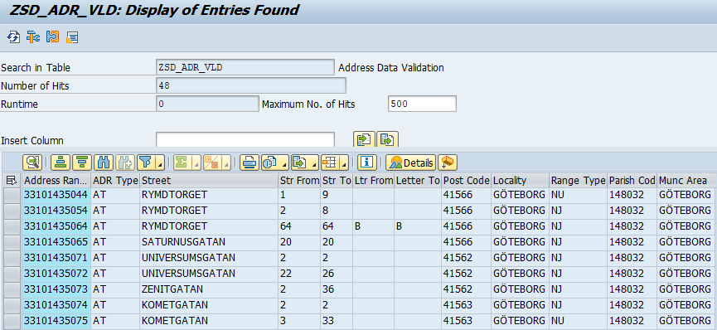
During processing of BP, it must be verified that
- BP postal code XYZ (415 66) is available in column POST_CODE
- BP city ABC (GÖTEBORG) is available in column LOCALITY
- Postal Code XYZ can be found in the same row as city ABC

In below case it must be verified that 172 65 and Sbg exist in the tables, and that both values can be found in the same row
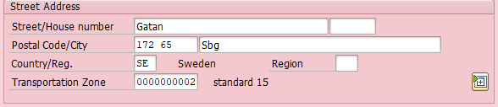

General Considerations:
- Postal Code – Country SE format has XXX YY in SAP in but XXXYY in reference table. When comparing postal codes, blanks in BP master data should not be considered.
- City Comparison should not be case sensitive.

System Behavior with invalid address

When trying to create (outside of integrations) or change a BP which address that does not comply with above, it should not be possible to save the BP.

It should be a red error message prompting:

EN: “Address does not match reference table ZSD_ADR_VLD”
SV: “Adressen stämmer inte överens med referenstabell ZSD_ADR_VLD”

Address Validation After Maintenance of Underlying Register

Once the underlying table, ZSD_ADR_VLD, for address validation is updated the existing BPs need to be validated.

The requirement is to run a report [available both in GUI and Fiori] (which should be triggered manually or through a job) that lists all BPs with an address that are out of range.

Selection Criteria for BPs for which address validation report is relevant
For reasons of flexibility there must be a table of criteria for which address validation report should apply [should be as any SAP input field, where specific values/ranges can be included or excluded]

Characteristic | Table-Field
BP Number | BUT000-PARTNER
BP Grouping | BUT000- BU_GROUP
Country Code | ADDR1_DATA- COUNTRY
Archiving Flag | BUT000- XDELE  There should be the possibility to  - Include BPs with archiving flag  - Exclude BPs with archiving flag

In case a field is blank there is no discrimination criteria [as a regular SAP input field]

Criteria for validating address

The criteria for validating address should be the same as in previous section

Report output

- The output of the report should list all BPs whose address is not compatible of the reference table.
- The out should be possible to export to excel

Technical solution specification

Error-handling and logging

Miscellaneous

Application management

…

Security

…

Authentication and authorizations

…

Testing

Testing information

Testing must be done for both online handling of BP and report to detect BPs that both valid and invalid addresses

Test cases

- Online: For each of the selection criteria test
  - Creation of BP with valid addresses via manual process
  - Creation of BP with valid addresses via integration
  - Change of BP with valid addresses via manual process
  - Change of BP with valid addresses via manual mass change

- Online: For each of the selection criteria test
  - Creation of BP with invalid (faulty city, postal code or combo, or incorrect address type) addresses via manual process
  - Creation of BP with invalid addresses via integration
  - Change of BP with invalid addresses via manual process
  - Change of BP with invalid addresses via manual mass change

- For report. For each of the selection criteria test
  - Verify that correct addresses are not listed by report
  - Cerify that invalid (faulty city, postal code or combo) addresses are listed

Closing

Risks

- ….

Suggestions for improvement

…

Open questions

….

Appendix

